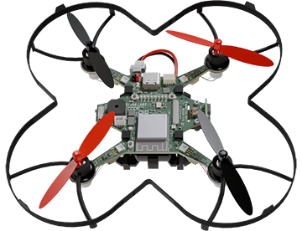

|  |  |
| --- | --- |
| **CodeAIR Mission 3 Assignment** | **Name:** |
| **Pre-Mission Preparation** | |
| You will be programming the LEDs for most of this mission. What code for LEDs do you remember? |  |
| You will also use CodeAIR’s speaker. What sound code do you know for CodeX or CodeBot? |  |
| **Mission 3 Checks** | |
| Objective #1  How can you turn off an LED?  How can you cause a delay in code execution? |  |
|  |
| Objective #2  How do you code an infinite loop?  What is the code for blinking an LED? |  |
|  |
| Objective #3  What is the problem with the code in CodeTrek? |  |
| Objective #4  How do you fix the problem from #3? |  |
| Objective #5  Why are the notes defined as constants?  What is the code for playing a sound? |  |
|  |
| Objective #6  Click on the RGB tool. A list of pre-defined colors is given. How many colors are readily available?  What is the difference between the user LEDs and the pixel LEDs? |  |
|  |
| Objective #7  Write the line of code that will flash all 8 pixels in sequence: |  |
| Objective #8  How are the lights designated for Standard Navigation Lights?  What is the code to create strobe lights? |  |
|  |
| **Post-Mission Reflection** | |
| What is a new concept you learned during this mission? |  |
| What is the difference between a while loop and a for loop? |  |